|  |
| --- |
| rEGGAErunningz LIMITED |
| 2D SHOOTER |
| **GAME PROGRAMMING1 ASSIGNMENT1** |
| Version 1.03  All work Copyright © 2015 by ReggaeMuffinz Games.  All rights reserved. |
| **HuAndre Barrett** |
|  |



**Insert a Company Logo here**

|  |
| --- |
| Oct 5th 2015 |

**Table of Contents**

Contents

Version History 3

Game Overview 4

Game Play Mechanics 4

Camera 4

Controls 4

Menu and Screen Descriptions 5

Enemies 5

Items 5

Vehicles 5

Script 6

Scoring 6

Sound Index 6

Art / Multimedia Index 6

Future Features 6

# Version History

The Github repository can be found here <https://github.com/cencolhubar/2D-Shooter>

# Game Overview

*The game consists of a police car that is driving on a stretch of road in hot pursuit of a gang of robbers who have just robbed a bank. As the robbers drive they release hazards in order to slow down the police but also inadvertently some of the gold coins they have stolen also escape. The object of the game is for the player to collect the coins and avoid the obstacle.*

# Game Play Mechanics

*The game automatically scrolls forward (I.e upwards, from a birds eye view perspective). You can use the left, right, up or down arrow to move the car in any direction. As you drive you will see coins appearing on the screen as it scrolls. Use the arrow keys to direct the player over the coins. You will also see obstacles. Use the arrow keys to avoid them. When coins are collected your points increase. Your points are displayed on your screen as you play. When you collide with a hazard you die. The option to restart your game by pressing the R button shows up on the screen when you die.*

# Camera

*Birds eye view perspective*

# Controls

*Arrow keys to direct the car*

*Spacebar shoots bullets*

# Menu and Screen Descriptions

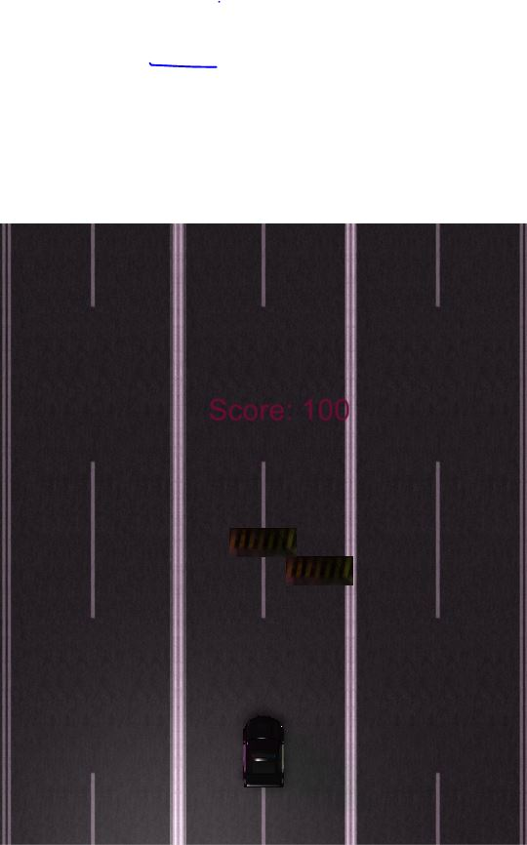

Main and only game screen

# Enemies

*The hazards that can kill the player if collided with are basically road block objects that can be seen on a construction site etc.*

# Items

*Users collect gold coins to increase their points*

# Vehicles

The main player vehicle is a police car

# Script

..\SpaceShooter-master\2D Shooter Assignment\Assets\Scripts

# Scoring

User points increase by 100 each time they collect a gold coin

# Sound Index

*..\SpaceShooter-master\2D Shooter Assignment\Assets\Audio*

* Police siren sound effect 1.mp3 – imported from youtube **https://www.youtube.com/watch?v=1G9mNBUymP8**
* Tokyo Drift Theme - Instrumentals (No Vocals AT ALL) – imported from youtube **https://www.youtube.com/watch?v=SDPXcvvxneg**
* The explosions, coin collecting sounds were taken from the Unity 3d Asset store from Game Sound Solutions

# Art / Multimedia Index

*All graphic assets were taken from unity 3d store from the following resources*

* CRCPV2-01
  + The Police car and robber car assets
* Road Blocker
  + The Road block obstacle asset
* Simple Modular Street Kit
  + The scrolling background asset
* 2D explosion force
  + The explosion asset

# Future Features

*Implementation of an AI controlled enemy i.e. the robbers being tracked by the police. The player will have to shoot them and blow them up to win the game.*